Stochastic and Modeling and Simulation Load Analysis
Norbert Doerry
June 8, 2026
- Introduction
When performing a load analysis, if there are loads with unusual power characteristics with respect to time, or multiple loads are correlated in unusual ways, then traditional load factor analysis or even zonal load factor analysis may not provide reliable estimates of the required rating of power system equipment.
DPC 310-1 identifies two alternate approaches. The first approach models each load as a probability density function (PDF); the total load is calculated via techniques such as Monte Carlo analysis to determine the probability density function of the total load. The second method models each load as a function of time. This function may be either deterministic; or it may have components that are probabilistic. The total system is modelled over an extended period of time to determine the maximum value that does not exceed the capabilities of the equipment over a given time interval.
- Stochastic Analysis
In stochastic analysis, individual loads are modelled as a PDF; the Monte Carlo method however, usually employs the related cumulative distribution function (CDF). A CDF is derived from a PDF through equation [1]. Four common PDF / CDFs are depicted in Figures 1-4.
$F_{X}\left(x\right)=\int_{-∞}^{x}{f_{X}\left(y\right)dy}$ [1]
Where
$f_{X}\left(y\right)$ = PDF of X
$F_{X}\left(x\right)$ = CDF of X
Figure 5 depicts the Monte Carlo simulation algorithm. The inverse transform technique may be employed to pick values of x that adheres to a given PDF; this technique is implemented with the following steps:
- Calculate the CDF from the PDF using equation [1]
- Create a sample u from a uniform distribution over the interval [0:1].
- Solve the equation $F_{X}\left(x\right)=u$ for x. x is a random sample from the PDF (Figure 6).
In stochastic analysis, loads that are correlated should be modeled with a single PDF. Loads are correlated if one load is more likely to be on if another load is also on; or if one load is more likely to be off if another load is on.
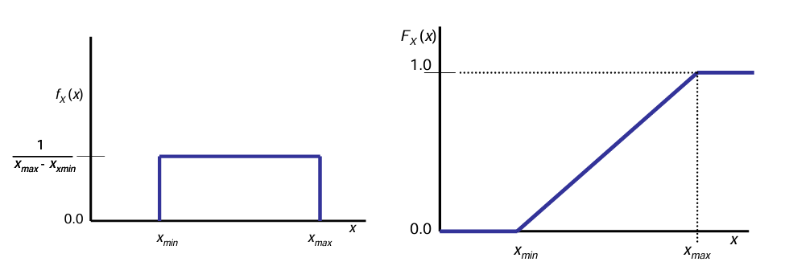
Figure 1: Uniform Distribution PDF and CDF (from DPC 310-1)
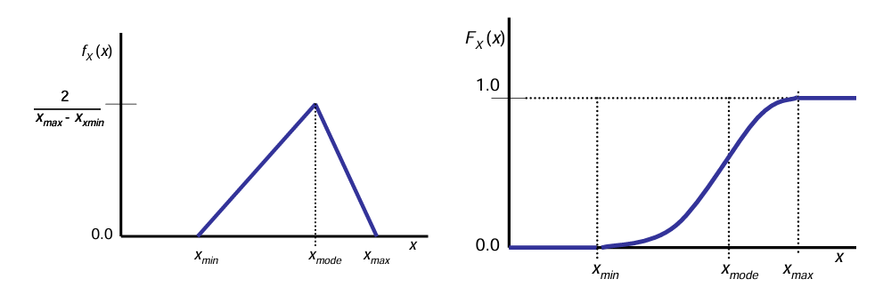
Figure 2: Triangular Distribution PDF and CDF (from DPC 310-1)
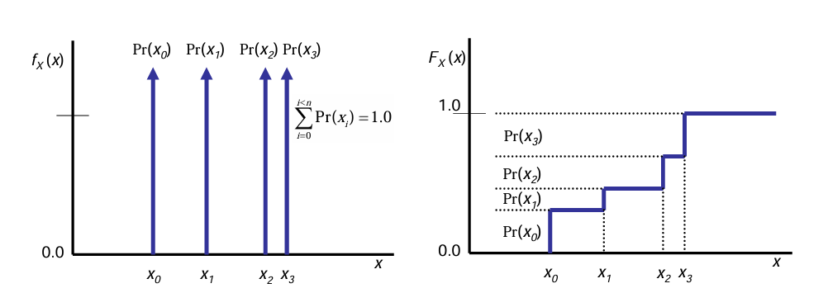
Figure 3: Discrete Distribution PDF and CDF (from DPC 310-1)
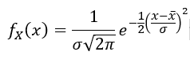
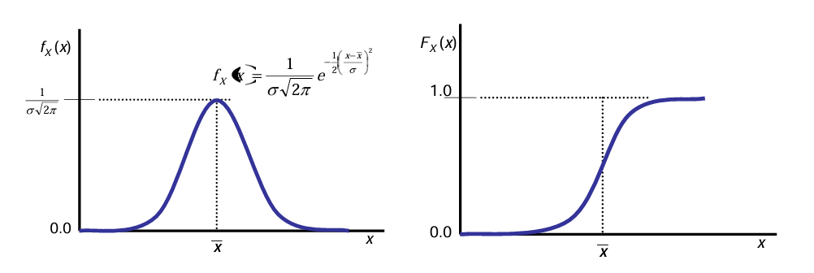
Figure 4: Normal Distribution PDF and CDF (From DPC 310-1)
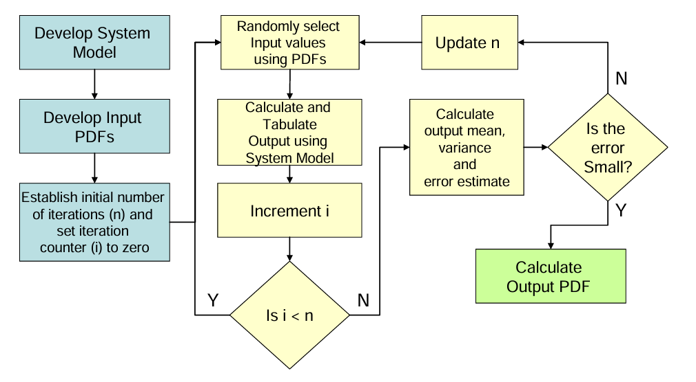
Figure 5: Monte Carlo Simulation Algorithm (From DPC 310-1)
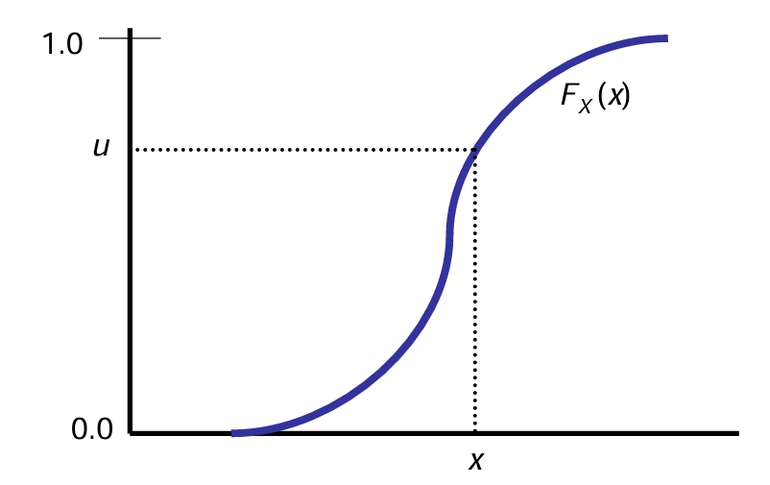
Figure 6: Inverse transform technique (From DPC 310-1)
Two of the critical steps in the Monte Carlo Simulation Algorithm are calculating the error estimate and evaluating if it is small enough. One method is to initially set the number of iterations (n) to roughly 500. For each iteration, generate a random value for each of loads based on its PDF and sum the loads. Calculate the mean value $\left(\overline{x}\right)$, standard deviation $\left(σ_{x}\right)$, and variance $\left(σ_{x}^{2}\right)$ of the set of n calculations for the total load using equations [2] and [3]:
$\overline{x}=\frac{1}{n}\sum_{i=0}^{n-1}{x_{i}}$ [2]
$σ_{x}^{2}=\frac{1}{n-1}\sum_{i=0}^{n-1}{{\left(x_{i}-\overline{x}\right)}^{2}}$ [3]
Equation [3] uses the term n – 1 in the denominator instead of n of the formal definition to reflect Bessel’s correction that accounts for the limited sample size of the PDF.
For a sufficiently large n, the error (E) as a fraction of n may be approximated by equation [4].
$E=\frac{3σ_{x}}{\overline{x}\sqrt{n}}$ [4]
Restating to determine the number of samples needed for a given error results in equation [5].
$n=\frac{9}{E^{2}}{\left(\frac{σ_{x}}{\overline{x}}\right)}^{2}$ [5]
A good value to use for E is less than or equal to 0.02. If for the chose value of E, the calculated value for n is greater than the number of iterations completed so far, then the additional iterations should be completed.
Once sufficient iterations have been completed, the PDF and CDF of the total load may be calculated. For equipment sizing purposes, the value of the CDF corresponding to between 0.95 (if short term overloads are tolerated) and 0.99 (if the equipment providing power only has a small overload capability) is typically used to determine the required rating of the associated equipment (after applying margin and service life allowance). For 24-hour average calculations, the mean value of the distribution should be used.
Robinson et al. (2006) employed stochastic analysis to determine the required rating of a medium voltage to low voltage transformer. Their analysis modified the traditional load factor analysis in the following ways:
- A discrete distribution was employed where the on-time probability (where the load is set to its connected load) is equal to the load factor and off-time probability is one minus the on-time probability.
- Load factors for air heaters was changed from 0.9 to 1.0 for the 10° F day
- A power factor was assigned to each load to determine the probability of current rather than power
- Intra-zone system loads are correlated to ensure loads that are always on together are modeled in that way; and loads that are exclusive are also modeled such that only one of them is on at any time.
- Inter-zone system loads are correlated in the same manner as item (d.)
Modifications c, d, and e are essentially the same as those necessary for the zonal-load factor method and should be generally employed in stochastic load analysis. Modifications a and b are modeling choices that depend on the details of a particular analysis.
Robinson et al. simulated the total load for the transformer thousands of times to determine a discrete probability distribution. Based on an analysis of the overload capability of the transformer, a probability of not exceeding the rated value of the transformer was set to 95% for the worst-case operating condition and ambient condition with margin and service life allowance applied was deemed acceptable.
- Modeling and Simulation Analysis
If there is a lot of interdependence among the loads, performing time-based simulations may be appropriate. The modeling effort can systematically capture when loads are correlated. As stated earlier, loads are correlated if one load is more likely to be on if another load is also on; or if one load is more likely to be off if another load is on. Unlike stochastic analysis, in modeling and simulation analysis, correlated loads need not be combined into a single model as long as the behavior of the two models are interconnected.
Generally, the time increment to use should be about 1 second … long enough to ignore in-rush current and many transients, yet short enough to be able to determine if an overload is significant enough to cause a service interruption for loads.
The time duration of the simulation for equipment sizing should be about 100 times the quality of service metric for mean time between service interruption (MTBSI). One factor of 10 accounts for allowing overloads to contribute only 10% of the allowed service interruptions; there are other sources of service interruption. Another factor of 10 improves the accuracy of predicting a mean time between service interruption. For a nominal 30,000 hour MTBSI requirement, this implies that 3 million hours (10.8 billion seconds) should be simulated. The full simulation need not be conducted at one time. An ensemble of shorter simulations may be employed; parallel processing enables performing each shorter simulation on a different processor at the same time.
For 24-hour average calculations, the mean value is desired. The length of time for simulation can be significantly shorter than for equipment sizing; 2400 hours (8.64 million seconds) should be more than adequate to determine an average value estimate.
Each of the load component models may either be completely deterministic, or may have stochastic properties. Doerry and Amy (2019) for example, recommend modeling a cycling load as depicted in Figure 7 and with the following random variables:
X_{on} = When online, the PDF of the time duration (sec) when the equipment is in the “on” mode
X_{off} = When online, the PDF of the time duration (sec) when the equipment is in the “off” (or “standby”) mode
X_{p_on} = when online, the PDF of the power consumed when the equipment is in the “on” mode
X_{p_off} = when online, the PDF of the power consumed when the equipment is in the “off” (or “standby”) mode
When the load is offline, the power is 0.
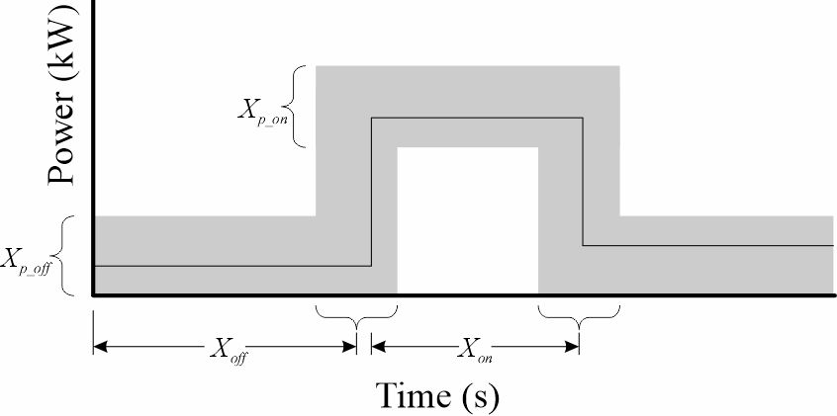
Figure 7: Stochastic load model of a cycling load
Often, the distributions are assumed to be uniform; the PDF is defined by a minimum and a maximum value.
The initial states of each of the loads should be based on the long-term probability of being in each of the states. This is particularly important when ensembles are employed.
Deter (2020) provides examples of power waveforms and associated load models for a number of shipboard loads from a U.S. Coast Guard cutter. Sievenpiper (2013) and Orji et al. (2015) describe how non-intrusive load monitoring (NILM) and other onboard load sensing systems may be employed to develop the time-based load models. Hatzilau et al. (2008) also provides insight on time domain modeling of shipboard loads.
In some cases, the power used by one load depends on how another load is behaving. Sarrico (2020) provides guidance on how to model this linkage for many shipboard components.
- References
DPC 310-1 Electric Power Load Analysis (EPLA) for Surface Ships
Deter, Thomas, “Creating a Shipboard Power Simulation Tool Using Electrical Load Behavior Modeling,” MIT thesis, May 2020.
Doerry, Dr. Norbert and Dr. John Amy Jr., "Electric Load Modeling," presented at ASNE Intelligent Ships Symposium, Philadelphia PA, April 9-10, 2019
Hatzilau, I.K., G.J. Tsekouras, J. Prousalidis, and I.K. Gyparis, “On electric load characterization and categorization in ship electric installations,” INEC-2008, 1-3 April 2008, Hamburg, Germany.
Orji, Uzoma, Bartholomew Sievenpiper, Katherine Gerhard, Steven B. Leeb, Norbert Doerry, James L. Kirtley, Jr., and Timothy McCoy, “Load Modeling for Power System Requirement and Capability Assessment,” IEEE Transactions on Power Systems, Vol. 30, No. 3, May 2015.
Robinson, Michael C., Wallace, Sara E., Woodward, David C., and Engstrom, Gene, "US Navy Power Transformer Sizing Requirements Using Probabilistic Analysis," SNAME Journal of Ship Production, Volume 22, Number 4, November 2006, pp. 212-218(7)
Sarrico, Ana Clara Rodrigues da Costa "Assessment of Ship Electric Power Consumption," Thesis to obtain the Master of Science Degree in Naval Architecture and Ocean Engineering, Technico Lisboa, December 2020.
Sievenpiper, Bartholomew, “Electrical ship demand modeling for future generation warships,” MIT Thesis, June 2013.

